Please join us in supporting Farmington Educational Foundation’s

Team Name:
Business Name:
Contact Person:
Phone Number: Email Address:

We would like to . . .

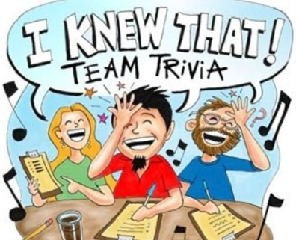 | ___ Register a Team  8 players $160 (if payment and registration postmarked by 1/19/24  $200 at the door  Amount Enclosed ____________

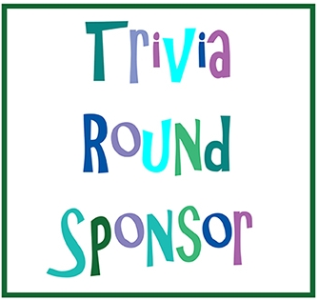 | ___ Sponsor a Round of Trivia  Each sponsored round is $50.  Round sponsors are recognized throughout the evening.  Amount Enclosed ____________

Make checks payable to
Farmington Educational Foundation
P.O. Box 1144
Farmington, MO 63640
Thank you so much for your support!

Questions? Contact sallyshinn@sbcglobal.net

